Product Architecture Design. AQUA MVP (Hackathon).
Owner: Sergii Iakovenko
Contributors: Juan Montoya (Architecture), Roman Pastukh (Product)

Latest update: November 10, 2025

Purpose and scope
This document defines the target architecture for the AQUA MVP (Hackathon), ensuring adaptive and future-proof development of the Frontend (Web UI) and solid integration with Backend (Server-side).

In scope: Frontend (Web UI), Backend for Frontend (BFF), mocked Backend APIs, mocked Authentication & Authorization.
Out of scope: API Gateway, Core Backend Services, SSO Authentication, Access Control, Backend Processors, AI Core, Audio storage, Database schema & configuration, Event bus & queues, Production deployments, Mobile apps, third-party integrations.

Architecture overview
The system is designed for flexible deployment across different infrastructure environments, allowing companies and teams of all sizes to meet specific performance, load, and cost requirements.

The user interface is implemented as a Single Page Application (SPA) Web UI, built using modern web technologies to deliver a highly interactive user experience.

The Frontend (Web UI) communicates with the Backend (Server-side) exclusively via RESTful APIs, which are exposed through a multi-tiered, service-oriented architecture designed for responsiveness, scalability, and maintainability.
This architecture is composed of three service categories:

Backend For Frontend (BFF): A dedicated service that sits between the Frontend and the Core Backend Services. Its primary function is to aggregate data, orchestrate complex requests, and tailor API responses to the specific needs of the Frontend.

Core Backend Services: A suite of stateless, decoupled microservices expose the business domain logic, handle data persistence, manage transaction integrity, and interact directly with the underlying database and storages.

Processing Services (Processors): These “worker” services manage asynchronous, resource-intensive, or long-running tasks. They are isolated from public API access and are driven internally by a message queue or event bus.

Data Stores: PostgreSQL serves as the primary database, storing structured entities such as call metadata, organization and user data, and application configuration settings. Audio Storage is used for persisting unstructured binary data, specifically the raw audio call recordings.

High-Level System Architecture

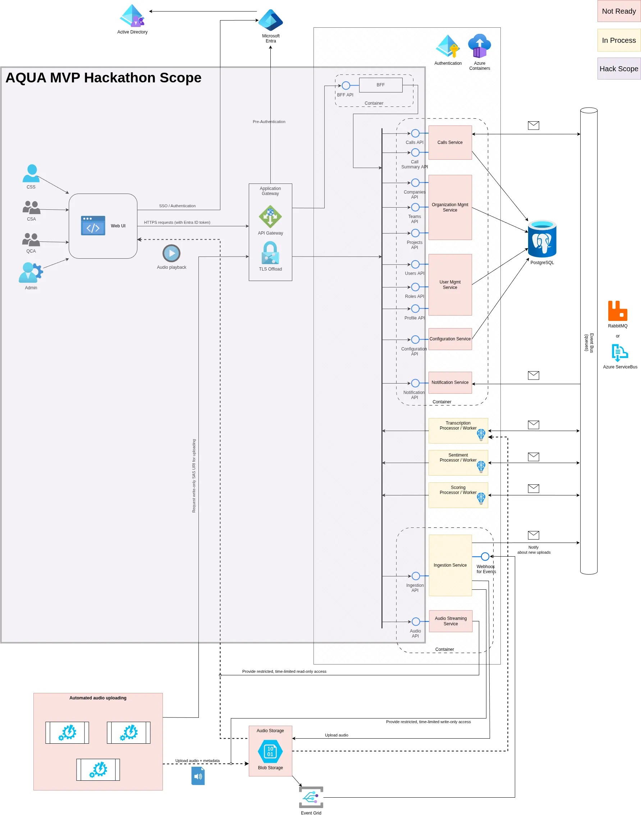

Components

Frontend (Web UI)
Single Page Application (SPA) designed for all user interactions, built for optimal performance, maintainability, and responsiveness across all major browsers and required devices.
Implementation: to be done by Hackathon participants.

Primary Framework: to be defined by Hackathon participants (e.g. React, Angular,Vue.js).
Language: TypeScript (strongly preferred) or JavaScript

Component Structure: to be defined by Hackathon participants and adhered strictly (e.g. Atomic Design, Feature-Based, or Layered structure).
UI Component Library: where necessary, utilize an open-source UI library only (e.g. Material-UI, Mantine UI, Bootstrap).

Global State Management: a single lightweight approach (e.g. React's Context, Zustand/Jotai).
Data Fetching/Cache Management: a single lightweight approach (e.g. React Query)

Interaction with Backend APIs: all communication uses JSON over HTTP(s). The API client is Axios.
Authentication: for the MVP, UI must implement a mock authentication mechanism (E.g. present a login view that accepts free-entry credentials for simulated access).
Access Control: for the MVP, UI must fetch and apply user role-based access control (RBAC) information. This data is to be retrieved via a mocked Profile API.

Build & Deployment: the build process must produce a folder with static assets ready for deployment to Azure Static Web Apps.

Testing: unit testing is mandatory for critical UI components and core business logic. Tools are industry-standard open-source testing frameworks and libraries.

Code Quality: enforced via industry-standard open-source code quality tools (e.g. ESLint, Prettier).

API Gateway
The single entry point for Frontend and external integrations to access the Backend services. Handles API traffic routing, TLS termination, and pre-authentication for services behind it.

Implementation: out of scope for the MVP.

Backend for Frontend (BFF)
The primary function is request orchestration and data aggregation, serving as an additional service available for Frontend. It's responsible for making multiple requests to various downstream Backend services, aggregating the result data, and transforming it into optimized payload tailored for specific UI needs. No business logic resides in the BFF.

Implementation: to be done by Hackathon participants.

Language/Framework/Libraries: to be defined by Hackathon participants, utilize open-source solutions only.

Scaling Rules: designed and configured for horizontal scaling.

Frontend-to-BFF communication: JSON over HTTP. The entry point for all requests routed to the BFF is the API Gateway.
BFF-to-Backend services communication: JSON over HTTP. Downstream service endpoints are managed via environment configuration. The authentication tokens (headers) are passed through to the relevant Backend services.

Resiliency: use retries and circuit breakers for all outgoing requests to downstream Backend services to ensure fault tolerance.

Build & Deployment: deployed as a containerized service.

Testing: unit testing is mandatory for data aggregation, non-trivial transformation, and shared presentation logic. Tools are industry-standard open-source testing frameworks and libraries.

Code Quality: enforced via the integration of static analysis tools into the build process.

Backend Core Services
The services manage all shared business logic, data persistence, state management, and configuration, thereby providing a reliable and consistent foundation for the rest of the system. They serve the Frontend, BFF and other internal services by providing the necessary APIs.

Implementation: for the MVP, these services are implemented as mocked APIs for the following functions: Calls, Organization Mgmt, User Mgmt, Configuration, Notification, Ingestion and Audio Streaming.

API Protocol: JSON over HTTP.
Authentication: out of scope for the MVP.

Frontend-to-Backend services communication: JSON over HTTP. The entry point for all requests is the API Gateway.

Deployment: deployed as a containerized service.

Data Flow

Authentication

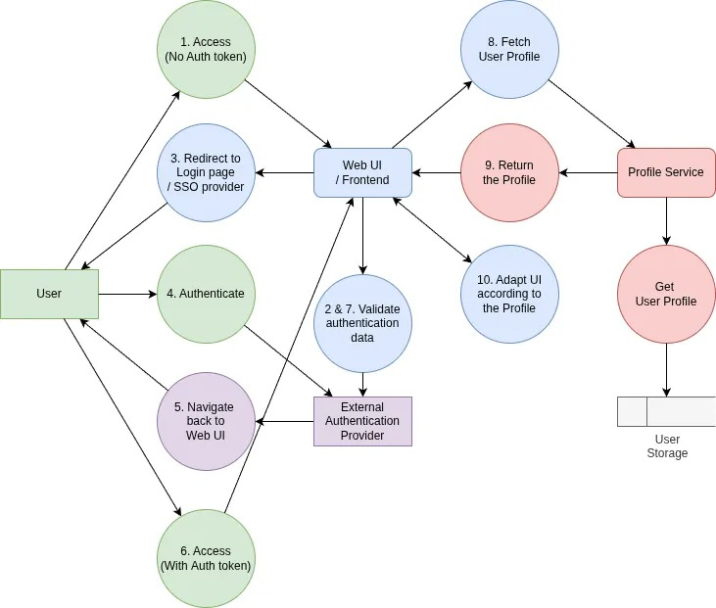

Manual Upload / Ingestion

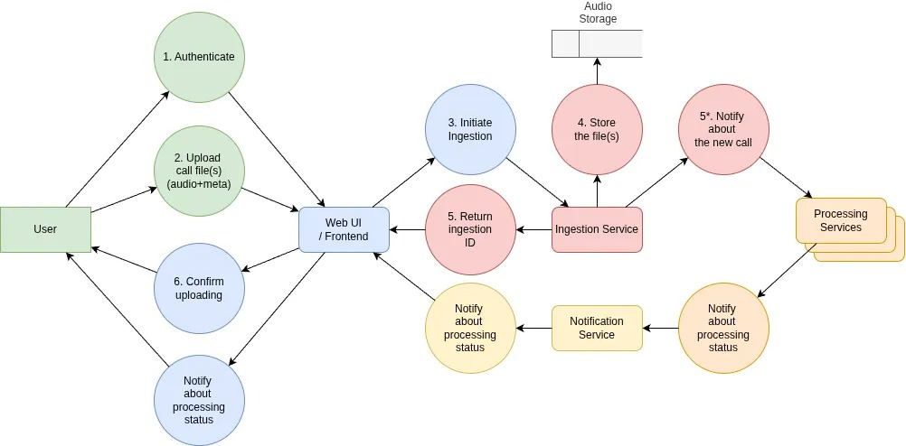

Call List / Details

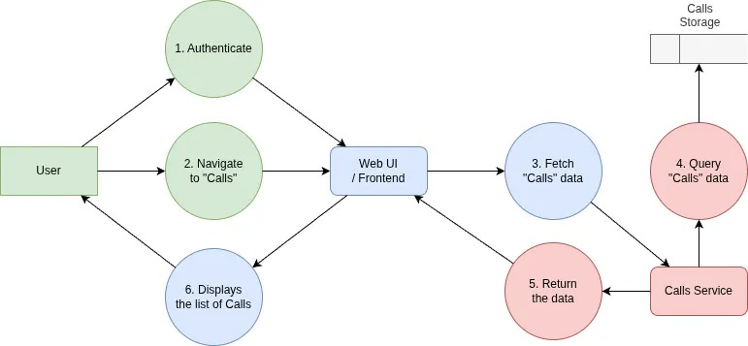

Interface contracts
The system leverages RESTful APIs for synchronous, request-response communication between Frontend and Backend, as well as among Backend services.

Backend For Frontend (BFF) Contract
This contract governs the APIs exposed by the Backend For Frontend (BFF) service, which are utilized exclusively by the Frontend.

Protocol: HTTP(S) (RESTful). HTTPS is mandatory for all external communication.
Data Format: JSON for request bodies and responses.
API Style: Resource-Oriented, specifically tailored for efficient UI consumption.
Versioning: URI Versioning (e.g., /api/v1/).
Authentication: Token-based
Error Handling: Standard HTTP status codes are used (e.g., 200 OK, 201 Created, 400 Bad Request, 401 Unauthorized, 404 Not Found, 500 Internal Server Error). Detailed error messages should be provided in the JSON body for client-side display or logging.
Contract Definition: Documented using OpenAPI Specification (OAS/Swagger).

Core Backend Services Contract
This contract defines the APIs exposed by the Core Backend Services, which are consumed by the Backend For Frontend (BFF), the Frontend, and other internal services.

Protocol: HTTP(S) (RESTful). HTTPS is mandatory for all external communication.
Data Format: JSON for request bodies and responses.
API Style: Pure Resource-Oriented (Microservice Style). Endpoints are designed to expose atomic business entities, focusing on the business domain logic.
Versioning: URI Versioning (e.g., /api/v1/).
Authentication: Token-based for client access, and Service-to-Service Authentication (utilizing internal API keys or service accounts).
Authorization: Implemented via Role-Based Access Control (RBAC).
Error Handling: Standard HTTP status codes are used (e.g., 200 OK, 201 Created, 400 Bad Request, 401 Unauthorized, 404 Not Found, 500 Internal Server Error). Detailed error messages should be provided in the JSON body for client-side display or logging.
Contract Definition: Documented using OpenAPI Specification (OAS/Swagger).

Deployment and Environment
The deployment strategy for the MVP is focused on functional validation of the Web UI and assessing the user experience. Production deployment is explicitly excluded from this phase. Environments are limited to a Local Development Environment and a Cloud Testing setup.

The Backend For Frontend (BFF) and mocked APIs (which simulate Core Backend Services) must be containerized.

The Frontend (Web UI) will be served based on the environment: either via a lightweight web server (like Nginx) or directly by the BFF for simplified local setups. In the Cloud Testing environment, it will utilize static hosting solutions (e.g. CDN or Azure Static Web Apps).

There must be the capability to execute the entire MVP within the Local Development Environment without any changes to the source code. While deployment to the Cloud Testing Environment must be restricted to configuration file adjustments only (e.g. endpoint definitions, environment variables)

Security and Privacy
Non-Production Data: Data utilized in the Local Development and Cloud Testing environments must be strictly limited to synthetic, anonymized, or fully non-sensitive data. Under no circumstances shall real customer, PII (Personally Identifiable Information), or production data be used.

API Communication: All communication between the Frontend and the Backend must be secured via HTTPS.

Authentication and Authorization: While the MVP is not production-ready, a mocked authentication and authorization mechanism must be implemented.

Input Validation and Sanitization: All data received from the Frontend must be validated against expected types and formats and sanitized before being processed by the Core Backend Services or persisted in the database.

Dependency and Vulnerability Management: Automated scanning tools (e.g. dependency checkers) should be used during the development and CI/CD process to identify and flag known vulnerabilities in third-party libraries and container images.

Container Security: Require that all container images are built from minimal base images and periodically updated to mitigate OS-level vulnerabilities.

Non-Functional Requirements Alignment
This section describes the design solutions, implementation approaches, and technical decisions that can be utilized to meet the Non-Functional Requirements (NFRs), which are specified in the PRD AQUA MVP Hackathon document and are expected to be satisfied by the MVP Hackathon outcome. The hackathon teams should avoid implementations that violate the NFRs and the overall system architecture design.

NFR1 Performance

Frontend Initial Load & Asset Delivery
The initial load of Frontend (Web UI) with a cleared browser cache must not exceed 2 seconds for 90% of user sessions.

To achieve this:
- SPA Web UI utilizes module bundling configured for code-splitting based on routes or features (lazy-loading).
- All static assets are minified (CSS/JS) and optimized (images) during the build process to minimize transfer size.
- Gzip compression is to be enabled at the server level for all text-based assets.
- Edge caching is to be configured for all static assets.

System Response Time
The system response time is measured from the user action (e.g., click, form submission) to the final visual update. The target response times are:
- Data-Involved Interactions: must be less than 500 ms for 90% of interactions requiring a round trip to the Backend for data fetching / modification.
- Client-Only Interactions: must be less than 100 ms. For interactions where data is already available or cached on client-side.

For data-involved interactions that exceed 500 ms, the Web UI must display an appropriate feedback mechanism (e.g., a loading spinner or progress bar) to acknowledge the action and inform the user of the ongoing process.

To achieve this:
- Set a time budget for Backend Service processing. The Time to First Byte (TTFB) is targeted to be less than 200 ms for 90% of requests, assuming a regional connection with network latency (RTT) of < 30 ms.
- Set a time budget for Frontend processing. Rendering and scripting time is targeted to be less than 100 ms.
- Minimize the data transferred in requests / responses, and rely on server-side paging, sorting, filtering and querying.
- Utilize server-side caching for static or precalculated data.
- Consider sending multiple requests simultaneously where appropriate to parallelize data retrieval.

NFR2 Reliability
The Frontend (Web UI) contributes to overall system reliability by ensuring a consistent and resilient user experience even when encountering temporary Backend or network issues.

To achieve this:
- The SPA has error handling mechanisms for data-involved interactions. It must ensure the Web UI remains operational and allows a user to initiate a retry (e.g. click an action button again, or perform a refresh).
- The SPA must implement mechanisms to keep crucial user-facing state locally (e.g. in-progress form data, current application view). This is necessary to support effective retry operations and enable a graceful recovery in the event of backend processing failure or temporary loss of network connectivity.
- The SPA must be designed with graceful degradation in mind: it should isolate the failure to the relevant component or feature (e.g., a specific widget or list) without causing a full application crash.
- A user must be provided with clear, contextual feedback (e.g., an error message, a "retry" button, or an indication that the data is stale).
- The SPA is required to maintain core functionality utilizing available data and features wherever possible, ensuring maximal continuity of service during partial system degradations.

NFR3 Compatibility

Browser Compatibility
Support the latest desktop versions of Chrome, Edge, Safari, and Firefox. No guarantees for legacy browsers.

Compatibility across mobile and tablet browsers is an inherent requirement, which will be achieved through the application of the responsive design principles detailed below.

Screen and Device Compatibility (Responsiveness)
The design must ensure that the application's layout, components, and interactive elements dynamically adapt to a diverse range of screen sizes and resolutions, spanning from desktop monitors to mobile devices.

Implementation will primarily leverage Responsive Web Design (RWD) techniques, utilizing fluid grids, flexible images, and CSS to guarantee an optimal and consistent user experience across all device form factors.

API Communication Compatibility
The Frontend's communication channel is limited to the RESTful APIs exposed by the Backend services.

Compatibility is managed through strict API versioning enforced at the Backend. This ensures that changes to the Backend do not break the existing Frontend.

NFR4 Security and privacy
The Frontend (Web UI) must communicate with the Backend via HTTPS to ensure all data transmitted between the client and the server is encrypted and protected from man-in-the-middle attacks.

The SPA must securely manage authentication tokens to maintain user sessions. The tokens must not be stored in client-side storage like localStorage but rather in a mechanism that mitigates Cross-Site Scripting (XSS) risks, such as HttpOnly, Secure cookies.

The SPA must not store any PII (Personally Identifiable Information) or system configuration secrets in unencrypted client storage.

All user input displayed or processed by the system must be sanitized and/or encoded before rendering to prevent XSS vulnerabilities.

The Frontend must implement a strict Content Security Policy (via HTTP headers) to restrict the sources of content (scripts, styles, images, etc.) that the browser is allowed to load.

All third-party frontend libraries and dependencies must be regularly audited and kept up-to-date to patch known vulnerabilities. Automated scanning tools must be integrated into the build process.

The code (both server- and client-side) must not contain any system configuration secrets. They are provided via secure environment variables.

The SPA must be configured to handle and display generic error messages to users, avoiding the direct display of technical, stack trace, or server-side error details that could aid an attacker.

NFR5 Maintainability
The SPA will adhere to a component-based architecture to ensure a clear separation of concerns, promote reusability across different application views, and isolate potential failures. Each shared component should be independently testable.

Implement lazy loading and potentially module federation to break down the large SPA into smaller and manageable chunks, reducing overall build times and improving load performance.

Enforce strict code quality standards using tools like ESLint and Prettier. These tools will ensure consistent code style, adherence to best practices, and automatic error detection, minimizing "style wars" and making the codebase uniform.

Maintain test coverage for critical SPA components and core business logic.

Prioritize the use of established, well-maintained libraries over creating custom, in-house solutions for common problems (e.g., date manipulation, form validation) to reduce the maintenance burden on the team.

NFR6 Testability
Use modern testing frameworks (e.g. Jest) to perform isolated unit and component testing of SPA components, core business logic, and utility functions. This involves using dependency injection or similar techniques to mock out dependencies, state management, routing, and HTTP requests.

Achieve high code coverage (>80%) for critical / reusable SPA components, core business logic and state management reducers/actions.

Test the SPA's reaction to various API responses, including successful data retrieval, empty states, validation errors (400 codes), authentication issues (401/403 codes), and server failures (5xx codes).

Network interactions and side effects must be managed in a way that is easily mockable and decoupled from SPA component logic.

All unit and component tests must be designed for seamless integration into the Continuous Integration (CI) pipeline to support automated, on-demand execution.

NFR7 Observability (SPA Web UI)
Implement structured logging across the SPA for key lifecycle events, significant user interactions (e.g. form submissions, page navigation), and received API responses/errors.

The SPA must capture and log all unhandled exceptions, runtime errors, and failed API calls. The SPA is designed to be integrated with an error tracking service (e.g. Sentry) to record the error stack trace, user context, browser details, and associated network request information.

The Frontend must be configured to generate a unique Distributed Trace ID, and propagate it as a header in all API requests. This allows linking client-side action to server-side processing (and subsequent API calls).

NFR8 Accessibility
The SPA interface must be fully operable using only keyboard input. This includes all core actions and critical functionality, eliminating the need for a mouse or other pointing device.

The default browser focus indicator must be enhanced with a clear and visually distinct focus styling. On page load, route transitions, or significant view changes, focus must be programmatically directed to a logical and relevant starting point.

The logical keyboard navigation sequence (tab order) must be correctly implemented across all views. This requires leveraging native semantic HTML and utilizing the tabindex attibute.

The Frontend (Web UI) implementation must be compatible with common assistive technologies (AT), primarily screen readers:
- Prioritize the use of native semantic HTML elements (<button>, <a href>, <form>, <input>) over custom elements where possible.
- All status messages, notifications, and error text must be exposed to assistive technologies using appropriate ARIA live regions. This ensures they are automatically announced by screen readers without the user having to shift focus.

All form fields must be explicitly associated with a visible and correctly positioned label. Error text must be visually apparent and explicitly associated with its respective input. The error state of the input must be communicated programmatically using ARIA attributes.

Any use of color in data visualization must be supplemented with labels, hover-text, iconography or pattern variations. This ensures that information is conveyed to users with color vision deficiencies.

NFR9 Build and runtime
The SPA must be compilable and bundled into production-ready static assets via a single, standardized command (e.g. npm run build). This command must execute all necessary steps, including transpilation, bundling, asset optimization, and minification. The build pipeline must integrate static analysis (e.g., ESLint) and unit test execution, enforcing a strict zero-error policy before artifact generation.

Running the SPA locally for development or demonstration purposes must be achievable using a single command (e.g. npm run start) after installation of dependencies.

Configuration variables (e.g. API endpoints, feature toggles) must be injected into the runtime via environment variables or a configuration service, not hardcoded. The necessary environment variables for the SPA's local execution, primarily specifying the API endpoints, must be clearly documented within the project's setup guide.

For the MVP, the SPA must only require connection to the Backend. No other external third-party services, monitoring tools, or proprietary APIs are necessary to demonstrate the core user experience and functionality.

References
- Hackathon Project Brief.docx
- PRD. AQUA MVP. Hackathon Outcome.docx
- Backlog. AQUA MVP. Current vs wanted state.docx
- API and Endpoints.docx

